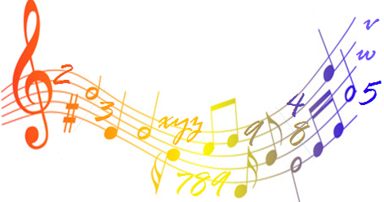

What: Free Math Review Session
Who: For All SAC Students
When: January 14-17, 22, 23, 2013
Where: SAC Math Center L-204


Math 81 Students

RESERVE
YOUR DLA APPOINTMENT
NOW!

